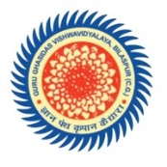 **DEPARTMENT OF INFORMATION TECHNOLOGY**

**SCHOOL OF STUDIES ENGINEERING AND TECHNOLOGY,**

**GURU GHASIDAS VISHWAVIDYALAYA, BILASPUR** (CENTRAL UNIVERSITY)

**CERTIFICATE**

This is to certify that the project entitled “IRRIGATION MONITORING WITH CONTROL SYSTEM USING IOT” carried out by “BALKARAN KUMAR (15107010) AND VIVEK BHARATI (15107030)” under my supervision at department of Information Technology, School of Studies Engineering and Technology, Guru Ghasidas Vishwavidyalaya, Central University, Bilaspur.

To the best of my knowledge and belief the report Embodies the work of the candidates themselves, Has duly been completed, Fulfils the requirement of the B.Tech degree of the University.

___________________

(Signature of the Supervisor)

Name: Anand Prakash Rawal

Designation: Assistant Professor